1. Log in to your Watson Studio, click Create a project to start our journey.

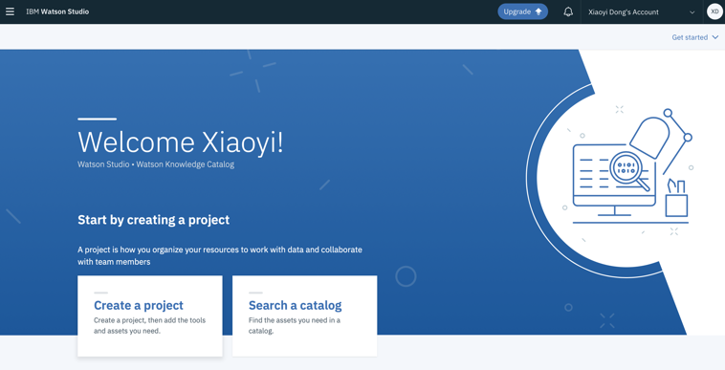

2. Click Modeler and give a Name and Description of your project



3.Click the Modeler flow



4. Give a Name and Description of your modeler flow, select Modeler Flow as flow type, IBM SPSS Modeler as Runtime.



**SPSS Modeler on Watson Studio**

In this tutorial you will experience how you can create, train and deploy a machine learning model from for customer churn. You will conduct the following tasks

- Connect to various types of data sources. You’ll merge the 2 files into 1 data stream.

- Split the data stream into training and a test partition

- Train the model using one of the auto-modeling nodes available in SPSS Modeler

- Evaluate and visualize the model performance in various ways.

- Use the generated model on a new data set to predict scores.

1.Login to your Watson Studio and create a **Model Flow** project

2.Import the dataset Customers.xlsx



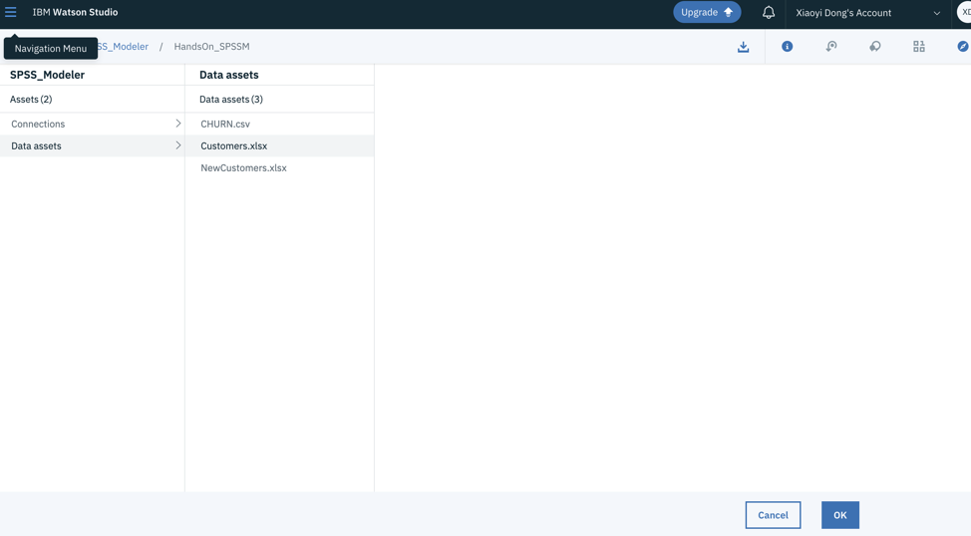

Click the Preview button to see the first 10 records in the file, an extraction of data from tele company’s CRM system. It includes historical data related to their customers’ demographics, purchasing behavior and segments. 

3.Import the CHURN.csv file



4.Connect Customer.xlsx and CHURN.csv to **Merge** node.



5.Double click the **Merge** node on the canvas to set the merge properties. Select **Keys** as the **Merge method**.

Select the **ID** field in the **Field name.** Click Save.



6. From the **Field Operations** palette, add a **Type** node to the canvas and connect it to the data source. Double-click on the Type node and click the **Read Values** button to scan the data as well as to display and update the range of values (we call this instantiate the data).

7. From the Output palette, double-click on the **Data Audit** node and connect it to the **Type** node. Right-click the Data Audit node on the canvas and select Run to inspect the data set. In the Audit tab of the resulting output, thumbnail graphs, storage icons, and summary statistics for all fields can be found. Double-clicking on any of the graphs will provide a more detailed outlook of the Field. In the Quality tab, information about outliers, extremes and missing values are shown. Click **run**.

8. After exploration,we will split the dataset into a test and a training partition. From the Field Operation tab in the palette drag a **Partition** node to the canvas and connect it to the Type node.Double click the Partition node on the canvas and set the partition sizes: We use the following split: 70% for training and 30% for testing.



9. From the **Modeling** tab drag an **Auto-Classifier** node to the canvas and connect this to the **Partition** node. Once connected the Auto-Classifier node on the canvas will be change to **CHURN** as this is the target we want to predict (we defined this in the Type node).

10. Click run then view the models Double click the CHURN node on the canvas to review the properties. On the Model tab you can set general properties how to build and rank the various models.



11. From the **Output** tab on the palette drag a **Table** node to the canvas and connect this to the **CHURN** golden node.

Click the **Table** node and select **Run** from the menu. Review the last2 columns of the table with the predicted value and confidence level.

Look at the last two columns of the table. The second to last column contains the predicted response outcomes, which can be compared to the historical outcomes in the 5th to last column; and the last column contains the confidence of that prediction. For example, the first record shows a customer who did, in fact, churned. The appended columns show that the model predicted that the customer would churn with 87.7% confidence.

12. To see the **overall accuracy** of the model, select an **Analysis** node from the Output palette, connect it to the **CHURN** golden nugget node. Click the **Analysis** node and select **Run** from the menu. You can review the accuracy for both the training and the test partition.

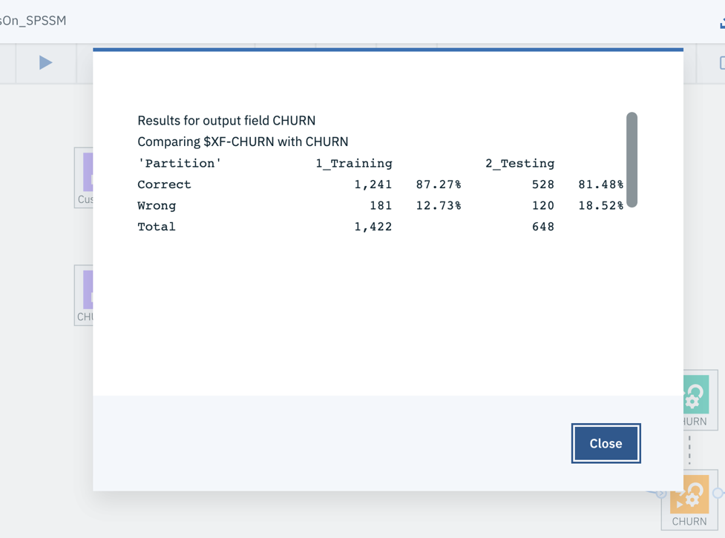

13.Work flow overview

